EX NO:11
DATE:
RAINFALL FORECAST REPORT

AIM: To analyze weather data from 2011 to 2018 using the Weather Data 1984–2018.xlsx dataset in Tableau and create a rainfall forecast report for the year 2019–20 based on historical rainfall patterns.
Given weather data of past 34 years, use the data from 2011 to 2018 and create a report on rainfall forecast for the year 2019-20. (Use Weather Data 1984-2018.xlsx Dataset)
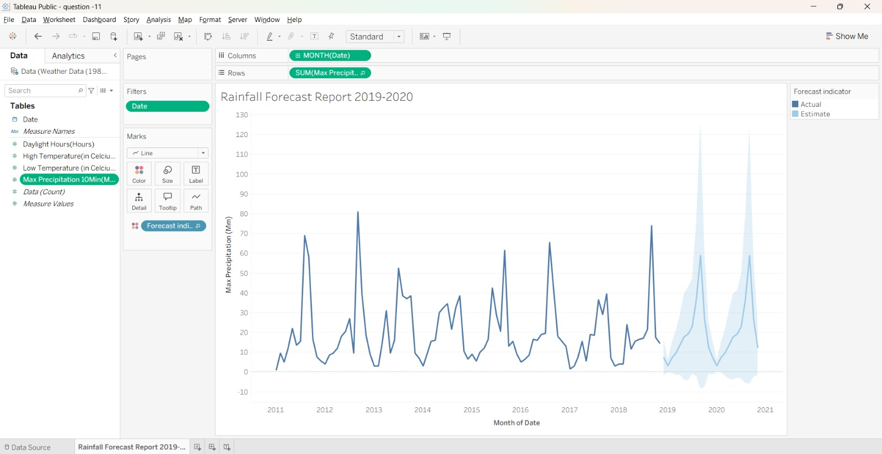

INTERPRETATION:
The rainfall forecast report helps analyze rainfall patterns from 2011 to 2018 and identify variations across the selected years. The forecasting visualization uses historical rainfall data to estimate future rainfall trends for 2019–20. It helps identify possible increases or decreases in rainfall and supports better planning for agriculture, water management, and other weather-dependent activities.

